**A PROJECT REPORT**

**ON**

**“A STUDY ON EMPLOYER BRANDING STRATEGIES” IN**

**“PENFOS SYSTEMS” BY**

**UTLA SAI GANESH HT. NO: 125020684116**

**UNDER THE GUIDANCE OF Mrs. T. KAMESWARI**



**Project submitted in partial fulfilment for the award of the Degree of BACHELOR OF BUSINESS ADMINISTRATION**

**BY**

**VIVEKANANDA DEGREE COLLEGE KUKATPALLY, HYDERABAD-500072**

**(Affiliated To Osmania University, Hyderabad - 500007) (2020 - 2023)**

## CERTIFICATION

This is to certify that the project report title **A STUDY ON EMPLOYER BRANDING**

**STRATEGIES** submitted in partial fulfilment for the award of BBA program of the Department of

Business Management, O.U, Hyderabad was carried by **UTLA SAI GANESH** under my guidance.

This has not been submitted to any other university or institution for the award of any Degree

/Diploma /Certificate.

**Mrs. T. Kameswari Signature of the Guide Hyderabad.**

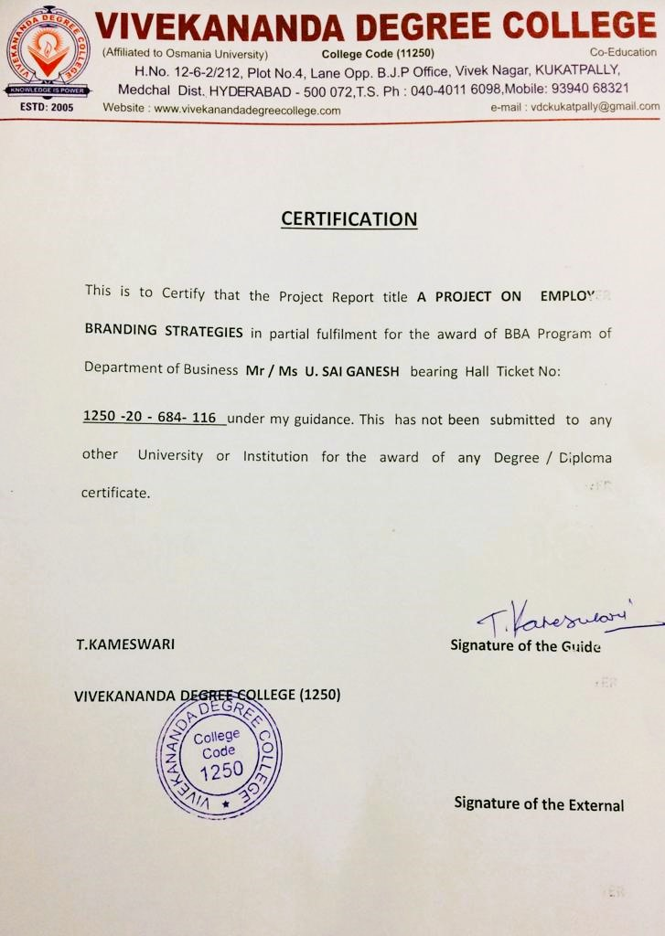



## DECLARATION

I hereby declare that this Project Report titled **“A STUDY ON EMPLOYER BRANDING STRATEGIES AT PENFOS SYSTEMS”** submitted by me to the Department of Business Management, Vivekananda Degree College affiliated to O.U. Hyderabad, is a bonafide work undertaken by me and it is not submitted to any other University or Institution for the award of any degree/certificate or published any time before.

**UTLA SAI GANESH Signature of the student Hyderabad.**

## ACKNOWLEDGMENT

With a profound sense of thankfulness, I acknowledge my indebtedness to my Faculty Guide **Mrs. T. Kameswari** for her valuable guidance, timely suggestions and constant encouragement. Her insightful criticisms and patience throughout the duration of this project has been Instrumental in allowing this project to be completed.

My sincere thanks to the Director **Mr. Dr. K. Naresh**, Principal, **Mr. B.N. Rajesh** & all the staff members of Department of management studies, Vivekananda Degree College for their consistent guidance in my project work. Their continual support and careful attention to the details involved in producing a document of this nature is very much appreciated.

**UTLA SAI GANESH**

**H.T.NO: 125020684116**

## ABSTRACT

The thesis focuses on employer branding strategy as a valid approach to human resources management in today’s challenging environment. Becoming an employer of choice and, in consequence, attraction, engagement and retention of high-performance workers or talents are the main goals of this strategy, able to become a source of sustainable competitive advantage and success.

The study provides a broad review of literature on employer branding strategy, rooted in resource-based view of the firm and the field of strategic human resources management. The concept is discussed in terms of its internal and external dimension (internal and external image of a company as a workplace), which ought to be consistent with employee value proposition laying in the heart of the strategy. Furthermore, its harmony and alignment with business strategy, as well as resulting for the organization advantages stemming from its implementation, are explained. The third part of the thesis provides a case study based on analysis of a PENFOS SYSTEMS. The examined company is considered to be a great workplace with an exceptional organizational culture and the study provides an analysis of determinants and outcomes of its employer image and employer brand.

|  |  |  |
| --- | --- | --- |
| **TABLE OF CONTENTS** | | |
| **Unit I** | **Introduction**   * Background of Study * Objectives * Scope of Study * Need of Study * Limitations | **9 -14** |
| **Unit II** | **Review of Literature** | **15 - 20** |
| **Unit III** | **Research Methodology** | **21 - 26** |
| **Unit IV** | **Theoretical Frame Work** | **27 - 31** |
| **Unit V** | **Company/Industrial Profile** | **32 - 38** |
| **Unit VI** | **Research Data Analysis & Interpretations** | **39 - 50** |
| **Unit VII** | **Research Finding & Conclusion** | **51 - 55** |
| **Unit VIII** | **Suggestion & Recommendation** | **56 - 58** |
| **Unit IX** | **Bibliography** | **59 - 63** |
|  | **Questionnaires** | **64 - 71** |

# UNIT – I INTRODUCTION

## Definition:

Employer branding establishes the identity of firm as an employer. It encompasses the firm’s values, systems, policies and behaviour towards the objectives of attracting, motivating, and retaining in firms current and potential employees.

**Acc. to Simon Barrow;** Employer branding can be defined as package of functional, economic, and psychological benefits provided by employment, and identified with employing company.

## Background of Study:

The struggle for retaining best employees in an organization is as much challenging as retaining customers. The shortage of skilled and competent applicants and difficulty in attracting and retaining skilled talents. The organization that overcomes the challenges to attract and retain the right employees become a successful firm. Employer branding techniques provides positive experience and proper employee engagement which in turn capture the core values of the organization

## Objectives of Employer Branding:

The objectives of this research are to examine the attributes that make an organization’s employer brand attractive to employees, this to be able to retain employees within the organization and to attract new ones. Moreover, a successful employer brand should be founded in the corporate brand and the corporate values of an organization to be attractive and successful. Therefore, this research also will identify if attributes in corporate branding are considered to be important to employees, as well as attributes from internal branding. The objectives also include examining if attributes in an employer brand vary in importance and attractiveness between different units in an organization. This to see if some attributes are more critical than others and need to be managed so that they are perceived more similar to employees in different units.

* + - **Flexible placement:** This is where an employee has opportunities to work in a variety of roles and settings within the organisation, where they have an interest in expanding their understanding. Employers should encourage staff to work in a variety of roles too.
    - **Performance focus:** Employees should use performance and benefit-based rewards to support staff development and keep them motivated. This might include additional days off or performance-related pay bonus.
    - **Project-based work:** Employees should have work structured around internal projects rather than organizational functions.
    - **Valuable work:** Work needs to be meaningful for staff. If tasks become menial or meaningless, it can cause them to become dis-engaged.
    - **Commitment is important:** Staff should be committed to the outcomes of the organisation, while employers should be committed to helping staff to do their jobs to the best of their abilities.
    - **Ongoing learning and development:** The company should encourage staff to learn and develop within the organisation. Whether that’s a certified CPD course or discovering the way another area of the business works professional development can be invaluable to employees.

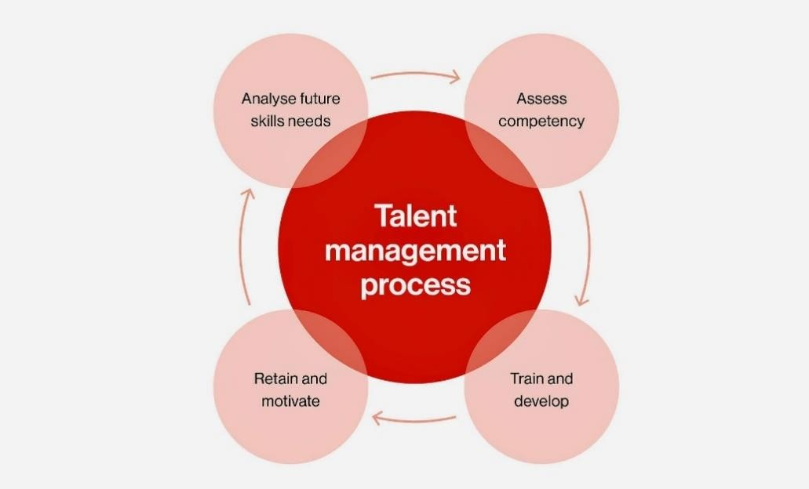

## Scope of Employer Branding:

* + - Employer branding is a relatively new approach toward recruiting and retaining the best possible human talent.
    - Managers can use employer branding as an umbrella under which they can channel different employee recruitment and retention activities.
    - Attempt towards studying the dynamics of employer branding can help companies to develop an employer branding framework.
    - Gives your candidates information about your corporate social responsibility or services to wider community
    - Helps the reputation of company in addition to helping plan towards creating positive brand.
    - Reducing cost per hire, this means that you can spend less on business branding with each candidate.

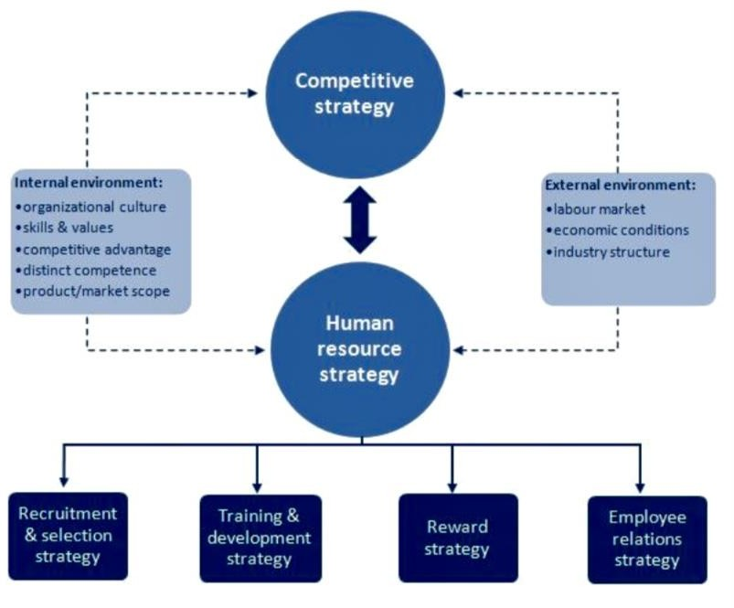

## Need of Study:

* + - **Employer branding builds Brand Identity:** Establishing and maintaining your presence online has become the need of the hour. Your future employees, as well as your clients, are visiting your website and observing you on your social media accounts. In addition to this, they are checking out what your current employees have to say about your company. Employer review websites like Glassdoor are most often visited during the job application period.
    - **Helps in better Talent Acquisition:** The main principle or the idea behind the whole concept of employer brand is to build your talent brand. Secondly, the employer brand helps you attract, engage, and retain the best and talented individuals in your organization.

Now-a-days, the recruitment process has become an enormous task which incurs costs and requires a lot of efforts from Human Resource team. Having an effective employer branding strategy not only helps you attract job seekers but also reduces the time required to fill the position.

* + - **Delivers a great candidate experience:** The recruitment process has evolved to be a candidate-centrism one. It is the candidates who choose and decide his employer. Job seekers nowadays are not only interested in what the company offers but also on what vision it holds and what environment it provides. So, a strong employer brand name will surely have a significant impact on the candidate’s decision to select his next employer.
    - **Ensures lesser employee turnover and better engagement:** Another benefit of employer branding is employee engagement and turnover, which is achieved only by hiring the right set of individuals. Your employer brand should reflect your work culture, the work environment, and the opportunities for the growth of your employees.

A great source of motivation for your current and potential employees could be a healthy working environment and ample opportunities for personal and professional growth.

* + - **Ensures financial stability:** With the recruitment market growing competitive, finding the right talent, and retaining it has become a costly affair. Advertising your jobs on various job portals, collaborating with recruiters, training the recruits, etc. comes with a cost. Companies with stronger employer branding do not have to put in a lot of effort into attracting exceptional talent. Their employer brand speaks for the company. This also means employer branding indirectly decreases the amount of time you spend on filling a position and its subsequent costs. Establishing a great employer brand is not a one-step process anymore. It is a continuous process that requires a lot of effort. It begins with understanding the importance of employer branding and its impact on your recruitment processes.

## Limitations of Employer Branding:

* + - **Expensive effort:** To create the employer brand, an organisation has to spend not only in terms of money but also a small committee or workforce specifically looking after to create an employer brand.
    - **If not implemented efficiently can lead to misrepresentation:** If the cell created for employee brand is not working in right direction, then might lead to misrepresentation.
    - **Requires extra time and effort:** To create an employment brand the organisation as required creating a separate cell/workforce/team that will lead work specifically to

build up employer brand. Thus, a part of employees is deviated specifically for this work.

# UNIT – II REVIEW OF LITERATURE

## Introduction:

To be a winning brand in the war for talent an employment brand needs to perform optimally in each of these dimensions. Ideally an employment brand should be credible, compelling, and connects emotionally with the organization's current employees and ideal recruits, marries the customer brand with the attributes of the workplace, it also uniquely differentiates the organization from others as well as authenticates and aligns with the values and culture of the current and potential employees. A strong employment brand begins with a promise that is credible, compelling, and connects to the applicant.

To be a winning brand in the war for talent an employment brand needs to perform optimally in each of these dimensions. Ideally an employment brand be credible, compelling, and connects emotionally with the organization's current employees and ideal recruits, marries the customer brand with the attributes of the workplace, it also uniquely differentiates the organization from others as well as authenticates and aligns with the values and culture of the current and potential employees. A strong employment brand begins with a promise that is credible, compelling, and connects to the applicant.

## Literature Review:

There is a plethora of theories about marketing and branding, and discussing corporate image and corporate reputation, however, there are only a few theories available concerning employer branding, especially the linkage between employer brand and consumer marketing communication methods.

* + - **According to Keller (1993)** brand equity elevated the importance of brand in marketing communication strategy and is often used to persuade customers to buy a product or service. However, in recent years, especially in today ‘s competitive market, employer branding is used to recruit and retain good employees from a diverse work force. Most companies tend to promote factors that make their firm a good place to work and also offering a bright and cheerful office space.
    - In 2002 **Sutherland, Torricelli, & Karg** told that it is really tough to attract and retain employees in a struggling organization. To become a successful business organization, retention of skilled employees is very crucial. Employer branding is a tool for attaining identity and reputation for corporate organization which further helps to portrait the values and icon to potential employees.
    - According to **Robert & Dowling (2002)**, superior performing firms have a greater chance of sustaining superior performance over time if they also possess relatively good reputations. It is consistent with the growing body of strategy research that links high quality intangible assets with sustained superior performance.
    - In a study, **Collins and Stevens (2002)** suggest that for intensifying employer brand image and to save the company from insolvency corporate branding plays an important role.
    - **Fulmer, Gerhart and Scott (2003)** made an analytical study on top 100 US companies regarding employer branding policies and found that policies formulated for building employer brand helps to

## Evaluation:

The concept of employer branding which has been increasingly popular since the 1990s means in the simplest terms the perception by the existing and potential employees of the company as the best place to work for. Employer branding has become crucial for many organizations as they all are keen to attract, develop and retain the right talent in their organization. Employer branding needs to attract and communicate to both potential employees and existing employees the attractive employee value proposition they have built. A strong internal as well external branding by organizations helps them to influence the employees' delivery of promised brand with the assumption of employees being satisfied with the organization (**Kaur & Syal, 2013**).

In today's era of boundary less, technology driven, rapidly changing business environment, one of the major corporate challenges is to meet the increasing demand for executive talent. The survival and success of organizations depend upon the quality of its workforce who can face the above challenges.

* + - **Chiu et al., (2020)** defined employer branding is an approach used by different companies to maintain their current employment and attract individuals to join the company. The practitioner and academic research have highlighted that developing effective employer branding strategies can provide a strategic advantage to the firm by developing engaged employees who are loyal and committed to the firm and work towards achieving the superordinate objectives of the firm **(Wilden et al., 2010)**.
    - **Biswas & Suar (2013)** defined employer branding to managing employer-employee relationships. It includes the employee's employment experience right from the start of the relationship in order to facilitate the retention of talented workforce.
    - **Bussin & Mouton (2019)** defined employer branding as a management strategy for retaining current employees and attracting the right talent.

While traditionally, branding efforts focuses towards development of corporate and product brands according to consumer perspective. The limitation and restriction for branding is no longer opt for products only. In the past, organizations used branding efforts to promote their products and services, recently branding strategies applied in human resource management, even organizations resorting to branding for attracting and retaining the best talent. Organizations realized that the appropriate way to become attractive in employment market is by having strong, distinguishable and clear employer brand **(Chhabra & Sharma, 2014; Gözükara, 2016; Kucherov & Samokish, 2016)**. Research also showed that the overall image and impression of the organizations in employees mind determines a lot of organizational outcomes, such as retention, employee engagement, loyalty, and better talent attraction **(Canhoto & Kietzmann, 2013)**.

* + - **Kaur & Syal (2013)** concluded that an effective employer brand is essential for satisfying its existing workforce. Another finding results from **Gözükara (2016)** also concluded that organizations can offer career opportunities and promotions, support a creative and innovative environment, conduct social responsibility projects, and provide above-average financial packages to their employees to build a strong employer brand, which in turn would enhance citizenship behaviour.
    - **Jain & Bhatt (2015)** stated that efficient employer branding enhances employee satisfaction and their willingness to remain loyal to their organization. Companies with higher involvement in employer branding are generally well managed and have employees who are motivated, continually learning, and growing. From the above definitions, it can be concluded that employer branding is an approach developed by organization for retaining current employees and attracting potential employees.

## Advantages of Employer Branding Strategies:

* + - Ensures that you retain best performing employees by promoting key company incentives and values. This strategy makes the employees more driven to advance and grow within the company and also adds the value.
    - Helps in organisation to reach targets and gain higher profits more easily because of increased workplace productivity.
    - Significantly reducing time for hire as your employees are act as ambassadors of company. As your strong identity brand empowers your employees, they will spread your positive company image and help in discover candidates faster.
    - Helps in saving on recruitment time and resources. This occurs because of your company image will have already been shape by your employer branding strategy and shared via recruitment marketing approaches.
    - Reducing your cost per hire because, as mentioned, employees are already promoting brand. This means less on sharing business.

## Disadvantages of Employer Branding Strategies:

* + - **You are not a good employer:** If you don’t treat your employees well, then its highly unlikely that you will have a good employer brand. With huge number social media sites, forums, and company review sites used on daily basis, if your employees aren’t happy, you can bet that it will get out into public view. So, before you start worrying about your brand look into other people and become a good employer.
    - **You don’t respect your candidates:** You need to make sure your candidates experiences are positive, respectful and fair. And if you can’t treat your candidates with respect, people will wonder how well you treat your employees and so on they’re even more likely to write bad reviews on social media.
    - **There’s no consistency:** One of the biggest issues you might have been when there is clear disconnect between employees and the brand you’re showing. Represent your clear and consistent employer brand in everything you do during the recruitment process.

# UNIT – III RESEARCH METHODOLOGY

## Research Approach:

The empirical contributions concerning the role of EB in HRM, has hitherto been few, which is why a descriptive and exploratory approach has been used. This thesis describes a specific phenomenon, its characteristics and outcome, and to permit this the data collection and analysis have been made with a qualitative approach. The purpose is to gain practitioners’ point of view and their perceptions of the existing theory in order to collect data in a close to reality setting, and a qualitative approach is to prefer when acquiring such data **(c.f. Ambler & Barrow, 1996; Roper & Davies, 2007; Punjaisri & Wilson, 2007)**, and also appropriate when the study is descriptive and there is a need for a deeper understanding of a phenomena **(Holme & Solvang, 1997)**.

**Furthermore, Yin (2011)** recommends qualitative research when investigating a real-world setting, and since the aim of this study is to examine in what way and why companies use EB in HRM, and therefore takes place in a highly real-world setting, the empirical framework is based upon a qualitative study.

**Merriam (1994)** describes the purpose of a qualitative approach as understanding the signification of a certain phenomenon and has its focus on processes instead of results. The importance of focusing on the process as well as the product **(Spiggle, 1994)** has led to a better understanding and the possibility to make interpretations and understanding the meaning and experience of the informants.

**Qualitative Research:** A qualitative research approach is a less formalized approach, which strives to get a more comprehensive and deep understanding. The qualitative research approach put emphasize on words rather than numbers when collecting and analysing data (Bryman & Bell, 2005).

## Case Study:

Due to the descriptive and exploratory purpose of this thesis and the need for a deeper understanding of the concept of EB, a case study is considered appropriate (c.f. Blumberg, B., Cooper, D. R., & Schindler, P. S. 2008; Saunders, 2008). Case studies are according to Bryman and Bell (2007) a research design that is commonly used in business and management research and it implicates an intensive and detailed examination of a single case.

The case of EB is a relatively new phenomena that has mainly been researched in theory and to get a deeper understanding of the subject Blumberg et al. (2008) suggest that a phenomenon needs to be studied within its context, and that multiple sources should be utilized to demonstrate different perspectives in order to allow comparisons and promote theoretical reflections on the results.

This is consistent with Merriam (1994) who suggests that case studies are applicable when the subject needs to be studied in its context and in depth. Multiple sources of evidence increase the possibility to render an analytical generalization (c.f. Blumberg et al., 2008; Yin, 2007). The phenomena of EB in an HRM context have thus been studied in more than one context in this thesis, to permit a general discussion regarding the practical application of the concept, since it until now mainly has been researched on a theoretical level. In other words, the case, which is the phenomena of EB, has been studied at the strategic and operational levels at five different companies, which are the contexts relevant for this study.

|  |  |  |  |
| --- | --- | --- | --- |
| **Research Strategy** | **Form of research questions** | **Requires control over behavioural** | **Focuses on**  **contemporary events** |
| **Experiment** | How, why | Yes | Yes |
| **Survey** | Who, what, where, how, many, how  much | No | Yes |
| **Archival analysis** | Who, what, where, how many, how  much | No | Yes/no |
| **History** | How, why | No | No |
| **Case study** | How, why | No | Yes |

## Research Sample:

To enable the study of the phenomena, the use of it and its importance, it needs to be analysed within its context. To permit comparisons and analytical generalizations regarding the phenomena of EB the research sample includes five companies that are knowledgeable and prominent within the subject. Since the purpose of this thesis is to investigate in what way and why companies use EB in HRM, the criteria for the sample selection were that the companies needed an expressed EB strategy and employer proposition. Furthermore, the criteria were a successful EB strategy, with respect to/and the selection was based on the List of Employers of the Year 2023 made by PENFOS SYSTEMS. is a global leader in EB that offers products and services to help clients attract, recruit and retain talent? The survey is conducted annually to identify and rank the best employers according to the perceptions of current employees. The result is based on three criteria; identity, satisfaction and loyalty at PENFOS SYSTEMS (2023). By studying companies that have managed to implement and communicate their employer brand strategy successfully, the aim is to gain knowledgeable practitioners’ views of in what way and why the concept can be used. Based on these criteria five companies were chosen; two specialist companies that are experts in the area of EB and three companies that have been acknowledged for their strong employer brands. The informants at each company were selected with respect to their positions at each company respectively, as well as their competence and knowledge regarding the subject of EB. The size of the firms or industries that the companies are active within has not been taken in consideration, which contributes to

a wider scope of information, and enhances the qualification of making more generalized acknowledgements. During the pre-research phase, an unwillingness to address potential failure concerning EB, or to admit that the company did not have an EB strategy, was observed. To increase the amount of data and to improve quality and validity of the information, the companies and the identities of the individual informants were anonymized. The responses from the informants should not be seen as representative for the specific companies, but as representative for the concept as such. Therefore, the selected companies are not specified by name or brand, but are instead re-named by the authors in order to keep track of them. The two EB specialist bureaus are named Castor Consulting and Pollux Consulting, and the chosen companies are named Athos, Aramis and Porthos. Castor Consulting and Pollux Consulting are consultancy firms that are specialized within the area of EB. They provide their clients with services regarding analysis and implementation of an EB strategy. The consultancy companies were selected as informants to provide the researchers with the professional view and specialist knowledge regarding how and why the employer brand is used in HRM. The pre-research was conducted through interviews and open conversations with two employees at Pollux Consulting; a partner and Head of Marketing Communication who also has served as HR Executive, as well as one Account Manager. The information received from the pre-research was also included in the result. The final interviews with informants at the consultancy firms were made with the aim of receiving initial knowledge and an overview of the subject.

## Research Limitations:

By anonymizing the companies and individual informants the possibility of acquiring and verifying information stated in this thesis is limited. However, there is no reason to misrepresent the information received from them, which is otherwise mentioned by for example Yin (2011) as a risk when using a qualitative approach and collecting data through interviews. Since the researchers were aware of this risk, the interviews were transcribed which made it possible to go back and verify the information. By undertaking a qualitative approach and collecting data through interviews the information received is more detailed and elaborated, compared to the use of a quantitative approach, which is why a qualitative approach is considered appropriate when studying a relatively new and unexplored phenomena that needs to be studied in detailed, in order to get a deeper understanding.

## Quality of Study:

A limitation with case studies is that the result cannot be generalized to an entire population. To at least increase the possibility of rendering an analytical generalization and to increase the validity of the study, multiple sources were used and the research sample contained companies ranging from small to large size from various industries. By choosing informants with different positions, such as HR Executives and EB Specialists, the scope of information is extensive and the description of the phenomena becomes more balanced since it includes several perspectives.

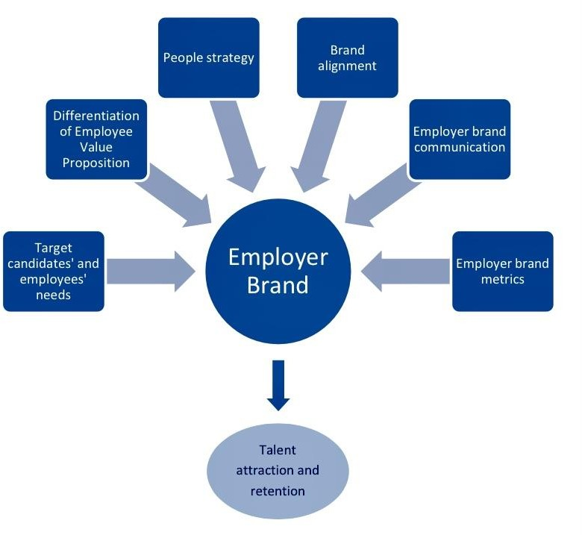

**Fig: Employer Brand Predictive Model**

# UNIT – IV THEORETICAL FRAME WORK

Employee Branding Strategies is arguably the least demanding conception. It focuses on the formal rules that stand in the way of achieving particular goals, such as employment and admission to schools. Different types of formal equality of opportunity can focus on many or few goals. What unites these views is a focus on formal discriminatory rules as an irrelevant obstacle to some role. Policies that are related to this conception include requirements that advertisements for jobs do not specify racial, religious or gender characteristics. They must be perfectly general such that anyone can apply without violating the formal rule. This vision of a free and equal society can be satisfied merely by ensuring that formal rules are properly general. So long as there are no formal rules that stand in the way of some individuals’ achievement of some goal those individuals have equal opportunity. The view is therefore compatible with private discrimination, implicit bias, and unequal distributions of resources.

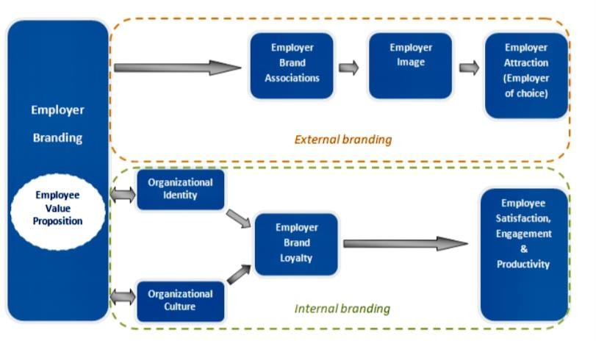

**Fig: Employer Branding Framework**

On the other hand, Employee Branding Strategies for Welfare is perhaps the most demanding conception of Equality of Opportunity. It focuses on welfare, or how well a person’s life actually goes, and not minimal welfare but equal welfare. Individual choice is the only relevant obstacle. So, the only thing that should stand in the way of an individual’s achievement of equal welfare should be their own voluntary choices. In other words, a person should be no worse off than others through no fault or choice of their own. If a person chooses to take risks or gambles, any resulting inequality would not be problematic, but if a person is a victim of bad luck, such as a natural disaster or disability.

This view is highly demanding and would require a radical redistribution of wealth to both those who are less naturally talented and to those who are otherwise disadvantaged through no fault of their own, for example, through upbringing, through natural bad luck as well as social class, racism, sexism and religious discrimination. Addressing these inequalities may require investing in schooling, sports facilities and social networks as well as healthcare and assistance for the disabled and heavily regulated jobs markets.

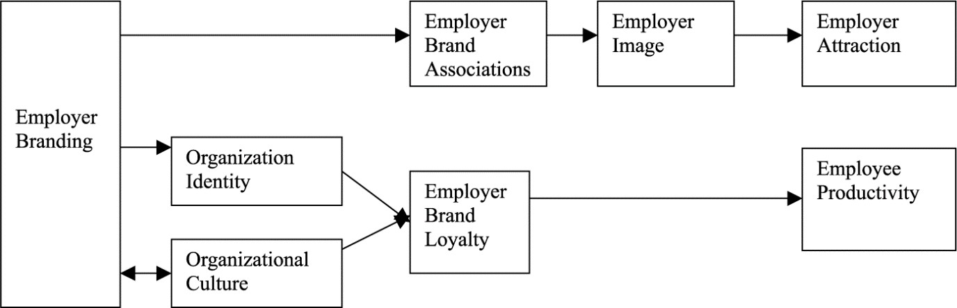

**Fig: Employer Branding Framework**

It should be noted that the more demanding the view the greater the encroachment on some putatively valuable forms of individual freedom. For instance, in order to ensure that wealth, social background and natural luck do not act as an obstacle for the poor it may be necessary to tax the earnings of the well-off. Some will claim that this violates the entitlements of the rich to their resources, and is therefore too high a price to pay. This may lead those people to accept a less demanding conception of Equality of Opportunity. Others will claim that taxing the wealthy is an acceptable price to pay to ensure that poor people have substantively equal opportunities to secure good jobs, adequate healthcare and education and to have means to support their families and live a decent life.

There are other conceptions of Employee Branding Strategies that are only moderately demanding. The two extreme views above, however, help us to see and make sense of dominant ideologies on the left and the right, and therefore historical public political disagreements. We can characterize much of contemporary political argument as

being about what the best conception of Equality of Opportunity is, which partly explains why it is such an important idea to understand.

Defenders of small government and individual responsibility on the right may be drawn to something resembling the conception of Employee Branding Strategies because going further requires interference with individual entitlements and a bigger state. They may go further than Formal Equality of Opportunity and instead favour the Meritocratic Conception of Equality of Opportunity, which requires redistribution to ensure that hard work and talent, and not discrimination and favouritism, determine hiring practices. Those who believe in meritocracy may consider some taxation to be a price worth paying for fairer hiring practices.

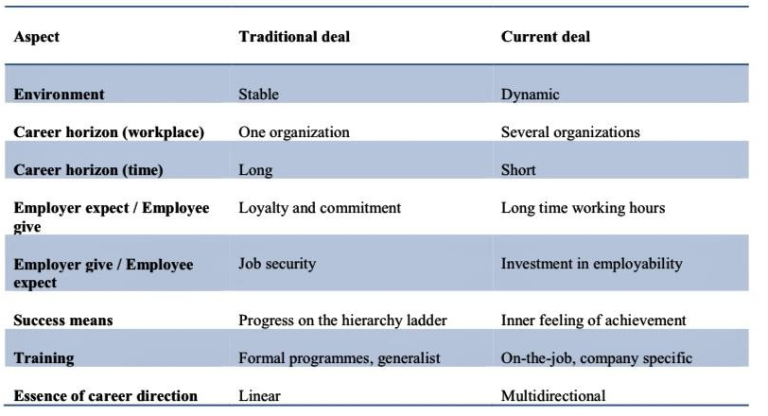

**Fig: Psychological contract b/w Employee and Employer**

Defenders of more substantive equal chances, who care about equalizing school quality and school funding, as well as providing for health care, will be drawn to more demanding ideals that more closely approximate Equality of Opportunity for Welfare. They may be put off by the demandingness of the conception of Equality of Opportunity for Welfare, and instead favor the conception of Fair Equality of Opportunity, which condemns inequalities in social background as obstacles to achieving valuable goals in life. Such a view will require redistribution to ensure that hard-working and talented individuals from the working class have the same chance of success as similarly hard- working and talented individuals from the middle and upper-classes. This kind of view

may advocate increased per pupil funding for the working-class. Evaluating the appropriateness of these ideals will be determined both by how well they express our commitment to freedom and equality.

These different conceptions of Employee Branding Strategies offer us very different guidance and assessment of our societies. The contemporary USA undoubtedly satisfies some conceptions more than others. In this way, we can see that which view is the best conception of Employee Branding Strategies will determine how much work we have to do to make progress and in which direction we need to go, whether that is breaking down formal barriers, eradicating nepotism and informal discrimination, or something more demanding like mitigating wealth inequality and the inequalities that follow from social class distinctions and natural disadvantages.

# UNIT - V COMPANY/INDUSTRIAL PROFILE

## Profile:

PENFOS SYSTEMS Pvt Ltd is an Offshore Software Development Company catering IT sector across the globe. We mainly focus in developing custom, scalable & secure applications leveraging outsourcing and offshore value advantage. We specialize in offering our services to what we believe are high growth industries.

On successful completion of the Market Research, the case-study is given to the Research & Development (R&D) division to conceptualize a cost-effective system that could potentially solve the customer's needs in a manner that is better than the one adopted by the competitors. Once the conceptual system is developed and tested in a hypothetical environment, the development team takes control of it. The development team adopts best suitable software development methodology to develop the proposed system and finally released with our customer satisfaction. While developing software, our company out sources the non-core activities to other companies who specialize in those activities. This accelerates the software development process largely. We work on tie-ups to bring out a highly matured product in a short period.

30

25

20

15

10

5

0

2010

2011

2012

2013

2014

Turnover rate in India

Turnover rate in Penfos Systems

**Fig: Turnover rate in PENFOS SYSTEMS in relation to nation turnover**

Turnover rate at PENFOS SYSTEMS is very low to national indicator, especially in 2014. It is related to employer brand loyalty, stemming from employee’s satisfaction, commitment and emotional attachment to company.

Inclusion at PENFOS SYSTEMS goes well beyond a focus on gender and race/ethnicity to also include sexual orientation, disability, generations, cultures, military status, well-being, and flexibility. It’s really about a focus on the whole person rather than a specific dimension, leading to an inclusive culture for all of our people. In turn, this provides us with a diverse workforce that possesses a variety of skills necessary to solve our clients’ complex challenges. Our inclusive culture is a source of opportunity, enrichment, and new thinking, and is why PENFOS SYSTEMS is a place where ALL leaders thrive.

Today, businesses demand global vision, an in-depth understanding of customers and suppliers, demonstrated thought leadership and a consultative partnership approach to offer the highest possible returns on IT investment. We help businesses achieve these ends. Working closely with our customers as transformation partners, we deliver, implement and maintain innovative software solutions across a number of technology platforms.

PENFOS SYSTEMS has proven expertise in the field of developing desktop applications. We develop desktop applications custom suited for your requirements and are easy to use Inventory Control solution to efficiently manage stock positions, item locations, etc. simultaneously at multiple warehouses and sale sites Sophisticated advanced pricing to enable multi-tier pricing Item tracking systems to manage records item receipts and transfers Stock control software to control production cycle, stock, order or supplier. Desktop solutions for the accounts such as general ledger and accounts receivable functionality for our clients. Financial management reports to Enhance Business process HR solution managing staffing information and payroll payments Payroll and Personnel system with automated facilities to support the payroll and personnel requirements of your business. Compact and easy to use ERP solutions that can be integrated into the desktop application.



Colleagues and atmosphere

Workplace/office Sense of security

Owners/Directors

Managers

Career opportunities

Benefits and social facilities

Care of employees

**Strengths of PENFOS SYSTEMS Employees**

**11%**

**7%**

**28%**

**8%**

**9%**

**13%**

**9%**

**15%**

### Specialized Services:

* Professionally designed templates available to suit different application requirements.
* Dynamic content, spellbinding graphics, stylized layouts and embedded sounds have transformed the very nature of website presentations.
* Flash based content creation for specific requirements with SCORM and AICC compliance.
* Customized web-based applications to fit business requirements.
* Flash communication server application supporting interactive multimedia applications like live audio and video Collaborations, interactive flash applications.
* Flash based E-Commerce.
* UI Designing for commercial websites and applications.
* Action scripting and back-end integration with remote applications.

## Our Vision:

Transformation partners to global corporations.

## Our Mission:

Leveraging technology and processes to help customers attain their goals.

## Our Values:

Drive business transformation for our clients, with a firm commitment towards [customer](http://www.zensar.com/about-us/vision-values#customer_sovereignty) [sovereignty,](http://www.zensar.com/about-us/vision-values#customer_sovereignty) passion for [continuous innovation,](http://www.zensar.com/about-us/vision-values#innovation) [transparency and integrity,](http://www.zensar.com/about-us/vision-values#transparency) and [people](http://www.zensar.com/about-us/vision-values#people_orientation) [orientation.](http://www.zensar.com/about-us/vision-values#people_orientation) At the same time, strive to maintain high standards of [corporate social](http://www.zensar.com/about-us/vision-values#csr) [responsibility.](http://www.zensar.com/about-us/vision-values#csr)

Worldwide software spending is expected to total $232 billion in 2010, a 5.1 percent increase from last year. Gartner analysts said the impact of the recession on the software industry was tempered and not as dramatic as other IT markets. In 2014, the majority of enterprise software markets will see positive growth.

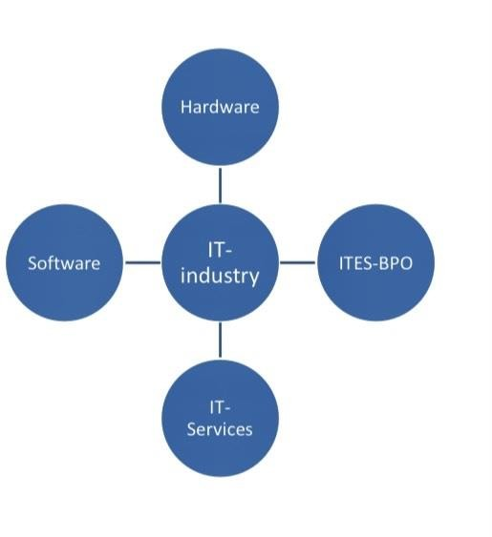

The industry is in an expansion mode right now, with dozens of new offshore IT services vendors emerging every day, the industry has a high probability of being subjected to the 80:20 rule in not too distant a future. In perhaps another ten years, 80 percent of all outsourced offshore development work will be done by 20 percent of all vendors, a small number of high qualities, trusted vendors. Only a few select countries and only the most professional companies in those countries, will emerge as winners. India will definitely be the country of choice for offshore software development. We have the potential to become and remain the country of choice for all software developments and IT enabled services, second only to the USA. The third choice could be far distant.

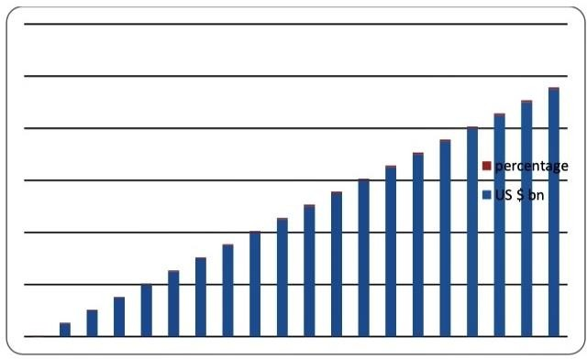

To become a global leader in the IT industry and retain that position, we need to constantly keep moving up the value chain, focusing on finished products and solutions, rather than purely on skill sets and resumes. We need to be able to package our services as products, rather than offering them as raw material. We need to be able to recognize and build up on our strengths and work on our weaknesses.

The IT industry has emerged as one of the most important industries in the Indian economy contributing significantly to the growth of the economy.

## Objectives of Company:

* + - To find out reasons for Quality of Work life in PENFOS SYSTEMS Pvt Ltd.
    - To find out effects of Quality of Work life in PENFOS SYSTEMS Pvt Ltd.
    - To find out way to improve Quality of Work life in PENFOS SYSTEMS Pvt Ltd.
    - To gain an insight into current working time policies and practices, as well as work life balance issues in PENFOS SYSTEMS Pvt Ltd.
    - To Complement Existing foundation data and research on working time largely based on surveys of individual workers and on literature reviews in PENFOS SYSTEMS Pvt Ltd.

## Awards & Rewards:

* + - MBLM Brand Intimacy Rankings and Brand Intimacy COVID Rankings-2020
    - Brandz Most Valuable Global Brand, 2019-2020
    - Brand Finance Global 500: World’s Most Valuable Brand, 2021
    - Forbes 50 Most Engaged Companies, 2017
    - Most Trust Worthy Company of the fortune 100, 2016
    - Inter-Brand Best Global Brand, 2020

# UNIT VI

**RESEARCH DATA ANALYSIS**

# & INTERPRETATIONS

## Data Analysis:

All the interviews were transcribed, translated and coded in order to facilitate the data analysis and to enable a comparison, both between the theoretical framework and the empirical findings as well as between the sources. The coding laid the foundation for the presentation of the empirical data received from interviews and other sources. Common themes were identified and assigned categories, which also enabled the analysis of the material (c.f. Spiggle, 1994).

The empirical presentation is built on statements both from Chapter 3 primary and secondary sources, and is outlined according to common themes, including both similarities and differences. Coding is considered the starting point in qualitative research and an instrument used for analysing data and is according to Bryman and Bell (2007) the process where data is divided into constituents and categorized according to the researchers’ interpretations. Transcribing the material reduce the risk of personal interpretations by the researchers and also allow them to go back and verify information received during the interviews. Collection and analysis were parallel processes, which means that analysis of the data occurred in connection to the data collection (c.f. Yin (2007).

The analysis is based on the research questions of why and in what way EB is used in recruitment and retaining purposes, where the first two parts focus on why, while the following three contains discussions of in what way.

* + - Illustrates the operationalization of the constructs found in the literature on employer branding. Each construct was broken down into several measurable items, ranging from at least two items up to four items on some constructs, which all were adapted from research within the field of employer branding. Hair et al. (2003) recommend that a construct should at least consist of three items, thus this was not the case on all the constructs in this research. The table also tells how the items were supposed to be measured - by using a 7-point Likert-scale.

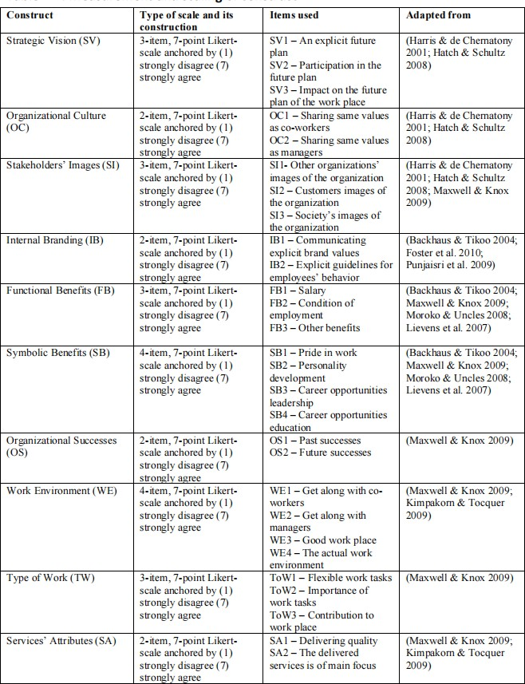

## Primary Data:

The primary data has been collected through personal interviews and telephone interviews. Interviews are one of the most important sources of information when conducting a case study. Interviews were conducted in person or via telephone and each interview lasted for approximately 40 minutes.

The interviews were of a semi-structured nature with ended questions in order to allow an open discussion with the respondents regarding the themes of the subject. According to Saunders (2009) semi-structured are applicable when the purpose of the study is descriptive. When the aim is exploratory Saunders (2009) also recommends keeping the interviews unstructured. This is characterized by both a descriptive and exploratory purpose, which is why an interview guide (see Appendix A) covering the fundamental issues was created in preparation for the interviews and used as a starting point for the discussion. To permit a comparison between the cases, the fundamentals of each interview were similarly designed.

The themes were concerned with the definition of the concept of EB, the role of EB in the recruitment process as well as the HR department’s utilizing and communication of the employer brand to the potential employees. The consultancy firms, Castor Consulting and Pollux Consulting, were asked to explain the implementation process of the employer brand strategy at their client companies. Athos, Aramis and Porthos were asked to describe the work with the employer brand at strategic and operational levels. The informants at Athos, Aramis and Porthos also discussed with the researchers which departments, within each company respectively, are involved in the EB management. Finally, the informants were asked how they measure how well they succeed in communicating and implementing the employer brand strategy.

## Secondary Data:

Secondary data was collected from each company’s website and other electronic sources and was used to complement the interviews and for contrasting the primary data. Recruitment advertising, descriptions of the firms as employers and other background information, for example from annual reports, were gathered to give full background information and to clarify the perceived employer brand of each company. Each firm respectively has a description on their website aiming to depict the values of the firm and what they offer them employees. One of the firms, Aramis, has a video on their website

aiming to present the firm as an employer and what the potential employee can expect if being recruited.

The descriptive statistics show that there were 70.7% males and 29.3% females. There were 62.6% teachers and 37.4% administrative staff who responded to the questionnaire survey. The minimum age group was 20–30, maximum age group were 50 and above, and 39% of the respondents lie in the 31–40 age bracket.

The marital status shows that 33.3% were married and 66.7% were single. Among the respondents 1.6% had matric qualification, 4.9% of intermediate, 24.4% of bachelors, 43.9% of masters and 25.2% of Doctorate level. The work experience of respondents shows that 35% respondents had 1–5 years of experience, 26.8%. of participants had 5–10 years of experience, 16.3% of respondents had 10–15 years of experience, 8.1% had 15–20 years of experience and 13.8% of respondents had 20 and more years of experience.

* Items Component 1 2 3 4 α
* Developmental Value: 0.9
* Our organization provides foundation for future employment 0.863
* Employees feel good about themselves as a result of working for our organization 0.802
* Employees feel more confident as a result of working for our organization 0.724
* Our organization provides experience that improves our career 0.719
* In our organization there is appreciation from management towards employees 0.504
* Interest Value: 0.88
* Our organization produces original products and services 0.78
* Our organization provides unique work practices 0.77
* Our organization provides an exciting work environment 0.73
* Our organization uses values and makes use of our creativity 0.71
* Our organization produces high-quality products and services 0.7
* Work/Life Balance: 0.86
* Our organization offers flexible work arrangements for employees 0.92
* Our organization looks after employees ‘work/life balance 0.79
* Flexible work arrangements offered by our organization enable us to be successful on and off the job 0.73
* Application Value: 0.8
* Our organization provides an opportunity to our employees to teach others what you have learned 0.77
* Our organization provides an opportunity to our employees to apply what you have learned 0.63
* Our organization is application oriented 0.52

|  |  |  |
| --- | --- | --- |
| **Particulars** | **No. of Response** | **Percentage** |
| 18-25 | 6 | 12 |
| 26-35 | 20 | 40 |
| 36-50 | 20 | 40 |
| Above 50 | 4 | 8 |
| Total | 50 | 100 |

* 1. Table showing age group of respondents

**Age Group**

45

40

35

30

25

20

15

10

5

0

18-25

26-35

36-50

Above 50

|  |  |  |  |  |  |  |  |  |
| --- | --- | --- | --- | --- | --- | --- | --- | --- |
|  | | |  |  |  |  | | |
|  | | |  |  | | |
|  | | |  |  | | |
|  | | |  |  | | |
|  | | |  |  | | |
|  | | |  |  | | |
|  |  |  |
|  |  |  |  | | |
|  |  |  |
|  |  |  |  |  |

Fig: 6.1 Showing the age response of employees

## INTERPRETATIONS:

From the above analysis it is clear that majority of the respondents for this study between 26-50 year of age. Organisation has the employees who belong to all Age groups.

|  |  |  |
| --- | --- | --- |
| **Particulars** | **No. of Response** | **Percentage** |
| Less than 1 Year | 0 | 0 |
| 1-5yrs | 8 | 16 |
| 5-10yrs | 24 | 48 |
| More than 15yrs | 18 | 36 |
| Total | 50 | 100 |

* 1. Table showing working experience of employees in PENFOS SYSTEMS Company

**Experience**

60

50

40

30

20

10

0

**Less than 1yr**

**1-5yrs**

**5-10yrs**

**More than 15yrs**

Fig: 6.2 Showing work experience of employees PENFOS SYSTEMS Company

## INTERPRETATIONS:

Most of the employees have more then 5years of experience in the organisation through which we can understand most of the employees are experienced.

|  |  |  |
| --- | --- | --- |
| **Particulars** | **No. of Response** | **Percentage** |
| Excellent | 4 | 8 |
| Very Good | 12 | 24 |
| Good | 20 | 40 |
| Average | 12 | 24 |
| Poor | 2 | 1 |
| Total | 50 | 100 |

* 1. Study on feeling of employees working for company

**Feeling of Employees Working**

45

40

35

30

25

20

15

10

5

0

Execellent

Very Good

Good

Average

Poor

Fig: 6.3 Study showing the feeling of employees working for company

## INTERPRETATIONS:

Most of the employees are feeling good to work in the PENFOS SYSTEMS. Ana they are liking to work continue their work in same company for more years.

|  |  |  |
| --- | --- | --- |
| **Particulars** | **No. of Response** | **Percentage** |
| Yes | 24 | 48 |
| No | 26 | 52 |
| Total | 50 | 100 |

* 1. Table showing the data of Information About Company to candidates

**Information About Penfos Systems Company**

53

52

51

50

49

48

47

46

Yes

No

|  |  |  |  |  |
| --- | --- | --- | --- | --- |
|  | | |  |  |
|  | | |  |
|  | | |  |
|  | | |  |
|  |  |  |  |
|  |  |  |

Fig: 6.4 Showing the data of Information About Company to candidates

## INTERPRETATIONS:

By this we understand that in the survey a greater number of the respondents says that the information about PENFOS SYSTEMS was less known to candidates.

|  |  |  |
| --- | --- | --- |
| **Particulars** | **No. of Response** | **Percentage** |
| PENFOS SYSTEMS | 9 | 18 |
| MNC’s | 28 | 56 |
| Micro Companies | 13 | 26 |
| Total | 50 | 100 |

* 1. Table showing the branding strategy in Market

**Branding Strategy in Market**

60

50

40

30

20

10

0

Penfos Systems

MNC's

Mcro companies

Fig: 6.5 Showing data of Branding Strategy in Market

## INTERPRETATIONS:

From the above analysis it is clear that majority of branding strategies are of MNC’s in the market with leading percentage. PENFOS SYSTEMS has less branding strategy in market than other companies.

|  |  |  |
| --- | --- | --- |
| **Particulars** | **No. of Response** | **Percentage** |
| Highly Satisfied | 26 | 52 |
| Satisfied | 8 | 16 |
| Neutral | 0 | 0 |
| Dissatisfied | 10 | 20 |
| Highly Dissatisfied | 6 | 12 |
| Total | 50 | 100 |

* 1. Table showing the opportunity to develop our skills in your job.

**Employer Branding of PENFOS SYSTEMS**

60

50

40

30

20

10

0

Highly Satisfied

Satisfied

Neutral

Dissatisfied

Higly Dissatisfied

6.6 Study showing the opportunity to develop our skills in your job

## INTERPRETATIONS:

Most of the employees have opportunity to have individual development. This will help them feel organization takes initiative to support its employees. Where they felt that they have to be committed towards organisation.

# UNIT VII

**RESEARCH FINDINGS & CONCLUSION**

## Findings:

Employer branding is considered strategically crucial to gain employee retention. Employer branding enables the employer to build an image in people ‘s mind that the firm is a great place to work. There is a significant positive relationship in development value and employee retention but there is no relationship between application value, interest value, and work /life balance and employee retention. Maybe the combined effect of other relevant dimensions would yield different results.

This finding supports preceding research that development value is a crucial value in employee retention. Hence, more the employees are appreciated due to their work, the more employees feel good about them and feel confident while working for that organization and that they would retain in the organization.

Later in 2017, two values i.e., management value and work/life balance were added in the dimensions of employer brand. In the similar year 2017, diversity value was another value added to the dimensions of employer brand. Until now, there are eight dimensions of employer brand and further we can recommend a ninth dimension that can be added to employer branding is psychological value. TTS aim is to improve the quality of the faculty serving the higher education needs of the country. Considering that the alteration must not change the fundamental spirit of the tenure track process of an open recognition of merit that is employment opportunity should only be offered to individuals based on excellence as per the set criteria in the relevant subject matter.

This is a significant development in the higher education sector of the country as it will have a dual effect on the overall higher education system of the country in context of the quality and volume of the new intellect that will be mentoring the future generations of the nation .Adm. Sci. 2018, 8, 44 12 of 15 The current findings reassert the concept given by social exchange theory and reciprocity theory, even though three of the four dimensions of

the employer branding under investigation do not show any direct relationship. These dimensions certainly play a significant role in employee retention indirectly through effecting employee satisfaction and commitment as per existing research, whereas the developmental value plays a direct role in enhancement of the employee retention levels in an organization which maintains a sound employer brand.

## Conclusion:

Although the findings from this research indicated that all ten attributes were important to employees there were some differences. The most attractive attributes of an employer brand to employees were the attributes of Work Environment, Type of Work and Services’ Attributes. Maxwell & Knox (2009) identified in their research that these three attributes were collectively more or less important among five different organizations and their employer brands. However, their research did not include an organization in the health care sector. Therefore, this research examined that these three attributes also were important in a health care organization, and moreover, they actually were the most attractive attributes in that organization.

In this study, the least attractive attributes of an employer brand to employees were the attributes of Stakeholders’ Images and Organizational Successes. Hatch & Schultz (2008) argue that Stakeholder’s Images play a central role in corporate branding. Moreover, Maxwell & Knox (2009) identified that Organizational Successes play a significant role as an attribute in employer branding. These two attributes refer to an organization as a whole and its corporate brand. In addition to this, Maxwell & Knox (2009), Foster et al. (2010) and Moroko & Uncles (2008) argue that the employer brand has to be integrated with the corporate brand of an organization to become strong. Even though, Stakeholders’ Images and Organizational Successes were attractive to employees in the health care organization, they were the least attractive ones. Therefore, these attributes that considered the aspects of a corporate brand were important, but the least important ones.

Furthermore, this may indicate that the three most attractive attributes that are closer to employees and their daily work in the health care organization are more essential than attributes considering employees’ interests in the organization as a whole. This can indicate that personal interests and the satisfaction of personal needs and wants among employees are of greater importance than the interests and satisfaction of the entire organization. However, it is recognized that employees at the health care organization 52consider attributes that are more than employment specific to be important for their employment in the organization.

The attributes of Strategic Vision and Organizational Culture also were attractive to employees. According to Hatch & Schultz (2008), these two attributes also play a central role in corporate branding along with Stakeholders’ Images. As argued by Maxwell & Knox (2009), Foster et al. (2010) and Moroko & Uncles (2008), an employer brand has to be integrated with the corporate brand of an organization. The fact that these two attributes were attractive and important to employees in this research indicates what Maxwell & Knox (2009), Foster et al. (2010) and Moroko & Uncles (2008) already have claimed is true. Punjaisri & Wilson (2011) and Foster et al. (2010) claimed that internal branding is linked to corporate branding. Further on, Foster et al. (2010) claim that internal branding, along with employer branding, can be seen as extensions of corporate branding. In this research, the attribute of Internal Branding was attractive to employees, which indicate that it was important to employees and their employment in the health care organization.

Therefore, it is argued that the concept of internal branding could be interlinked with employer branding. Furthermore, the attributes of Functional Benefits and Symbolic Benefits also were attractive to employees in the health care organization. Lievens et al. (2007) findings showed that Symbolic Benefits (feeling pride in belonging to an employing organization) were more important than Functional Benefits (salary, condition of employment) to current employees. However, this research indicates the opposite, even though the difference between the two attributes was not very significant. Therefore, it can be

said that the employees in the health care organization preferred Functional Benefits to Symbolic Benefits.

The three most important attributes varied in importance between units in the organization. The attributes of Work Environment and Services’ Attributes varied in importance among all the units in the organization, whereas the attribute of Type of Work varied among three units (Ambulance unit, Image- and functional unit (X-ray) and Care centers in Work District Y) in the organization. Another attribute, Symbolic Benefits, also varied in importance between all the units in the organization. Maxwell & Knox (2009) concluded that the attractiveness of attributes of an employer brand could 53vary between different organizations, based on the Social Identity Approach to Organizational Identification.

However, Ashforth & Mael (1989) argued that departments in an organization could perceive an organization differently, due to the fact that they belong to different social groups in the organization. In this research, employees in some units in the health care organization perceived some of the attributes differently. The variation between these units indicates that the units identify themselves with different social groups and therefore have different interests in the attractiveness of attributes. As Dutton et al. (1994) claimed that employees would become psychologically attached to an organization or department when they incorporate attributes of an organization or department into their own self-concepts. Therefore, the variation of the attractiveness of some attributes between units can be explained through the fact that the employees in these units are not psychologically attached to the organization in exactly the similar way.

To summarize, all the ten attributes included in the research were important to employees in the health care organization. The fact that the attributes were adopted from the literature on corporate-, internal- and employer branding indicates that these areas of branding is important in an attractive employer brand. However, it should be recognized that some attributes might vary in attractiveness between some units in an organization.

# UNIT VIII SUGGESTIONS

**& RECOMMENDATION**

## Suggestions:

* + - Organization should focus on improving relationship that is maintained between employer employees.
    - Organization should take necessary measures to make employees have good relationship.
    - Organization should provide some amount of autonomy to its employee to perform them work effectively.
    - Organization should build good relation with management within the workplace.
    - Organization should increase training programmed to its employees.
    - Organization should take time out to get to know employees personally.
    - Organization should take care about the conflict between the employees and between the management.

## Recommendation:

Based on the findings in the research, the researcher recommends the following:

* + - It is important for the telecommunication and banking sectors organizations to pay special attention to all components of ERM involving HR practices, communication, trust, leader ship styles and shared goals and values as important variables because of its great effect on employee performance on long term.
    - Organizations should have clear model for ERM. This model should contains every aspects for the employee relationships where ERM must be a new concept the organizations adopt and implement where the employees are the key success of any organization,
    - Organizations in both sectors should focus on training as a very helpful strategy for the employees to develop their skills and abilities to enable them carry the tasks on the right way.
    - Organizations should employ best HR practices to achieve consistently improving results in them employees’ performance.
    - Organizations should provide inspiring and effective leadership, open, transparent communication which will lead to motivated employees and good performance.
    - Organizations should improve communication within the employees through interchange ideas, feelings and opinions with management to strength the relationship with employees.
    - Organizations should open lines of communication which can improve employee’s relationships, and it should provide feedback, actively listening to employees.
    - Employees should be involved by organizations in decision making that will improve trust between them and improve their performance.
    - Managers in the both sectors should clarify goals and values, provide formal and informal feedback, and engage employees in open and honest dialogue, so they can improve the relationships they share with employees.
    - Managers also should clearly share their goals and values with the employees and make their efforts to actively clearly explain them are more likely to be successful and maintain good relationships with the employees.
    - Managers in organizations should earn employee trust and respect to strength the relationship with the employees and improve their performance.
    - Organizations need to figure out strategies for identifying, encouraging, measuring, evaluating, improving and rewarding employees’ performance at work.

# UNIT IX BIBLIOGRAPHY

## References:

* Ambler, T., Barrow, S. 1996.” The Employer Brand”, Journal of Brand Management. Vol.4, No. 3, p. 185 – 206
* Backhaus, K. Tikoo, S., 2004.” Conceptualizing and Researching Employer Branding”, Career Development International, Vol. 9, No. 5, p. 501-517
* Balmer, J. 2001. “Corporate identity, corporate branding and corporate marketing” European Journal of Marketing, Vol. 35, No. 3, p. 248-291
* Barney, J.B. 1991. “Firm resources and sustained competitive advantage”, Journal of Management, Vol. 17, pp. 99-120
* Barrow, S., Mosley, R. 2005.” The Employer Brand”. West Sussex: John Wiley & Sons Ltd
* Barrow, S. 2008.” A Brand-New View”, People Management, February, p. 7-8
* Belt, J.A., & Paolillo, J.G.P. (1982). The influence of corporate image and specificity of candidate qualifications on response to recruitment advertising. Journal of Management, 8, 105-112
* Berry, L. 1981.” Employee as Customer”, Journal of Retail Banking, Vol. 3, No. 1, p. 33-40
* Blumberg, B., Cooper, D. R., & Schindler, P. S. (2008). Business Research Methods (2nd Edition ed.). Maidenhead, Berkshire: McGraw-Hill Higher Education
* Bryman, A., & Bell, E. (2007). Business Research Methods (2nd Edition ed.). New York, NY, USA: Oxford University Press References 31
* Buck, H. & Dworschak, B. (eds.) 2003.” Ageing and work in Europe. Strategies at company level and public policies in selected European countries”. Demography and Employment. Öffentlichkeits- und Marketing strategy demographischer Wandel.
* Davies, G. 2008,"Employer branding and its influence on managers", European Journal of Marketing, Vol. 42, No. 5, p. 667 - 681
* Dew-Becker, I. & Gordon, R.J. (2008) The Role of Labor Market Changes in the Slowdown of European Productivity Growth. NBER Working Paper No. 13840
* Foster, C., Punjaisri, K., Cheng, R. 2010,"Exploring the relationship between corporate, internal and employer branding", Journal of Product & Brand Management, Vol. 19, No. 6 p. 401 – 409
* Gaddam, S. 2008. “Modeling Employer Branding Communication: The Softer Aspect of HR Marketing Management”, The Icfai Journal of Soft Skills, Vol. 2, No. 1, p.45- 55
* Greening, D. W. & Turban, D. B. (2000). Corporate social performance as a competitive advantage in attracting a quality workforce. Business & Society, 39(3), 254-280.
* Holme, I. M., & Solvang, B. K. (1997). Forskningsmetodik: Om Kvalitativa och Kvantitativa Metoder (2nd Edition ed.). Lund, Sverige: Studentlitteratur
* Kotler, P. H. 1991, Marketing Management: Analysis, Planning, and Control, 8th ed.
* Englewood Cliffs, NJ: Prentice-Hall. Inc.
* Lievens, F. & Highhouse, S. 2003. “The relation of instrumental and symbolic attributes to a company’s attractiveness as an employer”, Personnel Psychology, Vol 56, p. 75-102
* Kunerth, B. & Mosley, R. 2011,"Applying employer brand management to employee engagement", Strategic HR Review, Vol. 10 No. 3 p. 19 – 26
* Martin, G., Gollan, P. & J., Grigg, K. 2011. “Is there a bigger and better future for employer References 32 branding? Facing up to innovation, corporate reputations and wicked problems in SHRM”,
* The International Journal of Human Resource Management, Vol. 22, No. 17, p. 3618- 3637
* Maxwell, R. & Knox, S. 2009. “Motivating employees to “live the brand”: a comparative case study of employer brand attractiveness within the firm”, Journal of marketing management, Vol. 25, No. 9-10, p. 893-907
* McKinsey & Company, Inc. 2001. “War For Talent”.
* Merriam, S. B. 1994. Fallstudien som forskningsmetod. (B. Nilsson, Trans.) Lund: Studentlitteratur
* Moroko, L. & Uncles, M. 2008.” Successful Employer Brands”, Brand Management, Vol. 16, No. 3, p. 160-175
* Mosley, R. 2007.” Customer Experience, Organizational Culture and the Employer Brand”,
* Journal of Brand Management, Vol. 15, No. 2, p. 123-134
* Punjaisri, K. & Wilson, A. 2007. “The role of internal branding in the delivery of employee brand promise”, Brand management, Vol. 15, No. 1, p. 57–70
* Roper, S., & Davies, G. 2007. “The Corporate Brand: Dealing with Multiple Stakeholders”.
* Journal Of Marketing Management, 23(1/2), p. 75-90.
* Sartain, L. 2005.” Branding From the Inside Out at Yahoo: HR’s Role as a Brand Builder”, Human Resource Management, Vol. 44, No. 1, p. 89-93
* Saunders, M. 2009. Research Methods for Business Students. Harlow: Financial Times Prentice Hall.
* Spiggle, S, 1994. “Analysis and Interpretation of Qualitative Data in Consumer Research”.
* Journal of Consumer Research, Vol. 21, No. 3, p. 491-503References 33
* Sullivan, J. 2004, “Eight elements of a successful employment brand”, ER Daily, 23
* February. Retrieved 2012-11-13 from [http://www.ere.net/2004/02/23/the-8-elements-](http://www.ere.net/2004/02/23/the-8-elements-of-a-successful-employment-brand.com) [of-a-successful-employment-brand.com](http://www.ere.net/2004/02/23/the-8-elements-of-a-successful-employment-brand.com)
* The Conference Board. 2001. “Engaging Employees Through Your Brand”. New York.
* Universum, 2012. “Sveriges Bästa Arbetsgivare 2012”. Retrieved 2012-10-15 from <http://www.universumglobal.com/IDEAL-Employer-Rankings/Sveriges-Basta-> Arbetsgivare
* Yin, R. K. 2007. Fallstudier: design och genomförande. (B. Nilsson, Trans.) Malmö: Liber
* Yin, R. K. 2011. Qualitative Research from Start to Finish. London: The Guilford Press

# QUESTIONNAIRE

### I am UTLA SAI GANESH a final year student of VIVEKANANDA DEGREE COLLEGE, Department of Bachelor of Business Administration, Hyderabad and presently doing a project on “EMPLOYER BRANDING STRATEGIES” Hyderabad. I request you to kindly fill the questionnaire below and this will be only for my study purposes.

1. **Name:**

### Gender:

1. **Name of the organization:**

### Department:

1. **Designation:**

### Age group:

a) 18 to25year b) 26 to 35 years

c) 36 to50years d) Above 50 years

### How many years in total have you been working at this workplace? By workplace we mean the site or location at, which you work.

a) Less than1year b) 1 to 5years

c) 5 -10years d) More than15years

### In general, how would you describe relations between managers and employees in this organisation?

a**)** Excellent b) Very Good

c)Good d) Average

### Is it important for management to build relation within the workplace?

a) Yes b) No

### What types of training programme is undergone here?

a) On- the job training b) Off- the job training

### Should management take time out to get to know employees personally?

a. Yes b) No

### What’s the most important or key aspect builds workplace relation?

a) Communication b) benefits

c)Trust d) Giving time

### Is conflict always a bad thing inorganizations?

a. Yes b) No

### Organization has poor workplace relationship between employees?

a. Yes b) No

### In general, how much influence do you have over the following?

**A: The tasks you do in your job**

a) A lot b) Some

c)Little d) None

e) Don’t know

### B: How you do your work

a) A lot b) Some

c)Little d) None

e) Don’t know

### How satisfied are you with the following aspects of your job?

**A: There is scope for your own initiative**

a) Strongly agree b) Agree

c)Neutral d) Disagree

e) Strongly disagree

### B: The training you receive

a) Highly Satisfied b) satisfied

c) Neutral d) Dissatisfied

e) Highly dissatisfied

### C: There is opportunity to develop your skill in your job

a) Strongly agree b) Agree

c) Neutral d) Disagree

e) Strongly disagree

### In general, how good would you say managers at this workplace are at keeping employees informed about the following?

**A: Changes to the way the organization is being run**

a**)** Excellent b) Very Good

c) Good d) Average

e) Poor

### B: Changes in staffing

a) Excellent b) Very Good

c) Good d) Average

### C: Changes in the way you do your job

a**)** Excellent b) Very Good

c) Good d) Average

e) Poor

### Overall, how satisfied are you with the amount of involvement you have in decision making at this workplace?

a) Highly Satisfied b) Satisfied

c)Neutral d) Dissatisfied

e) Highly dissatisfied

### Are you satisfied with incentive scheme providing in the organization?

a) Highly Satisfied b) Satisfied

c) Neutral d) Dissatisfied

e) Highly dissatisfied

### Do you have training facilities to promotion your skill?

a) Highly Satisfied b) Satisfied

c) Neutral d) Dissatisfied

e) Highly dissatisfied

### Do you have canteen facilities if so, are you satisfied?

a) Highly Satisfied b) satisfied

c) Neutral d) Dissatisfied

e) Highly dissatisfied

### Do you have transportation facilities to the workers if so are you satisfied?

a) Highly Satisfied b) Satisfied

c) Neutral d) Dissatisfied

e) Highly dissatisfied

### Does company provides job security for the workers?

a) Highly Satisfied b Satisfied

c) Neutral d) Dissatisfied

e) Highly dissatisfied

### Company provides benefits to motivate good relations between workers?

a) Highly Satisfied b) Satisfied

c)Neutral d) Dissatisfied

e) Highly dissatisfied

1. **Does Company provide good working conditions?**

a) Highly Satisfied b) Satisfied

c)Neutral d) Dissatisfied

e) Highly dissatisfied